WOTUS Update
August 30, 2018

In February 2017, President Trump signed an executive order directing the EPA and Department of the Army to review the 2015 WOTUS rule for consistency with the stated policy that it is in “the national interest to ensure that the Nation’s navigable waters are kept free from pollution, while at the same time promoting economic growth, minimizing regulatory uncertainty, and showing due regard for the roles of the Congress and the States under the Constitution.”

The agencies are implementing the President’s executive order through a two-step process of repealing and revising the definition of “waters of the United States.” Here’s an update:

July 12: The EPA and Department of the Army published in the Federal Register a supplemental notice of proposed rulemaking to seek additional comment on the agencies’ proposal to repeal the 2015 WOTUS rule and restore the regulatory definitions used prior to the 2015 rule, in part because they propose to conclude that the 2015 rule exceeded the agencies’ authority under the Clean Water Act.

August 13: The public comment period on the supplemental WOTUS repeal notice concluded at 11:59 PM ET.

August 16: Judge David Norton of the U.S. District Court for the District of South Carolina in Charleston ruled that the 2015 WOTUS rule can go into effect in the 26 states not currently covered by injunctions from district courts in North Dakota and Georgia. EPA spokeswoman Molly Block told the Washington Examiner that the “EPA and the Army [Corps of Engineers] will review the order as the agencies work to determine next steps.”

The American Farm Bureau Federation and a broad coalition of industry groups are planning to appeal the decision and, in a recent filing, asked the court to stay its order. Farm Bureau Senior Director of Regulatory Relations Don Parrish discussed the effort on RFD-TV, which you can watch HERE.

DTN The Progressive Farmer has compiled a helpful map showing (in red) the 26 states where WOTUS is now in effect:

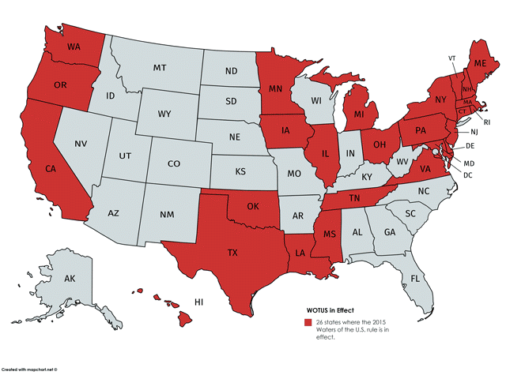

What’s Next?

September 2018 (estimated): The EPA and Department of the Army are expected to submit and publish a notice of proposed rulemaking for the revised WOTUS definition. Acting EPA Administrator Andrew Wheeler recently told reporters that the replacement rule is “going through interagency review, hopefully coming for notice and comment soon.”

November 2018: According to the Office of Management and Budget, the agencies are expected to publish a final ruleon repeal of the 2015 rule and reinstatement of prior regulatory definition and begin to seek comments for a proposed revised WOTUS rule.

September 2019: The EPA and Department of the Army are expected to publish a final rule on the revised WOTUS definition.

