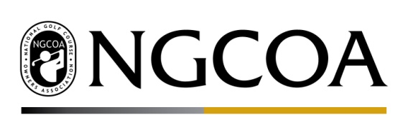

Golf Businesses and Current Labor Issues

Golf sustains two million American jobs, with $55.6 billion in annual wage income. One out of every 75 jobs in the United States is impacted by the golf industry. The golf industry needs a trained, legal, and available workforce in order to keep golf facility doors open for business and support American jobs. However, certain federal labor policies are negatively impacting the golf industry.

- H-2B Visa Cap Relief –The H-2B Nonimmigrant Temporary Worker visa program enables the golf industry to fill crucial seasonal jobs when American workers are unable or unwilling to fill them during the high season. However, the program’s statutory cap of 66,000 visas per fiscal year is far too low to satisfy the staffing needs of seasonal employers. In addition, countless employers experience unnecessary 30 to 60-day delays in the processing of H2-B applications.

  - Take Action: Support current initiative by a group of lawmakers including Senators Tillis, Rounds and Representative Harris which have negotiated an H-2B package as part of the
final 2019 Department of Homeland Security Spending bill that if approve would;

    - Permanently double the annual cap to 132,000
    - Permanently double the annual H-2B cap to 132,000 visas and require the Department of Labor to report to Congress every two years about whether or not the cap should be increased or decreased based on economic need;
    - Allow some agricultural related industries to access the uncapped H-2A program, including forestry and conservation-related services relating primarily to the cultivation, installation, and establishment of horticultural commodities;
    - Provide for proportional and quarterly allocations of H-2B visa so that businesses have access to workers regardless of their dates of need;
    - Preserve access to the program for compliant seasonal employers;
    - Provide access to needed temporary workers involved in disaster and recovery efforts;
    - Increase fines and penalties for bad actors;
    - Require employers who use the program to e-verify the work eligibly of recently hired and newly hired employees; and
    - Eliminate the costly newspaper advertising requirement and replace it with a requirement to list jobs through an online Department of Labor job registry.

