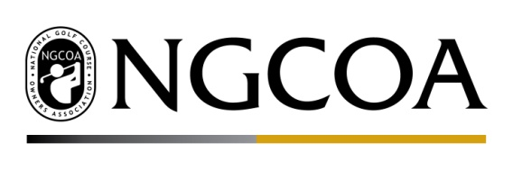

Golf Business Exclusions in the U.S. Tax Code 2018

Since the 1970s, provisions in the U.S. Tax Code have singled out golf businesses and limited their access to important development and redevelopment tax credits. The golf industry was arbitrarily lumped into a group of “Sin List” businesses, and golf facilities are negatively impacted by this harmful prevalence of small businesses in the golf industry, and the industry’s positive economic impact. As of 2014, 95% of golf facilities met the Small Business Administration definition of a small business. Further, golf impacts two million american jobs, with $55.6 billion in annual wage income, and an approximately $3.9 billion annual charitable impact.

COMMUNITY ECONOMIC DEVELOPMENT AND REDEVELOPMENT CREDITS: The U.S. Tax Code includes provisions stating that no portion of the proceeds of the issue of certain small issue bonds and redevelopment bonds may be used to provide for private or commercial golf courses or country clubs. This language is also referenced in other parts of the tax code, including provisions on special rules for capital gains invested in opportunity zones, empowerment zone employment credits, enterprise zone businesses, tax-exempt enterprise zone facility bonds, and the new markets tax credit.
REQUEST: Please support the removal of language that arbitrarily excludes golf businesses from accessing development and redevelopment tax credits. The time has come for critical reevaluation and removal of these outdated tax policies that punish golf businesses. Golf businesses seek access to the same opportunities as their counterparts in other sectors.
RELEVANT LANGUAGE: Section 144 provisions on small issue bonds and redevelopment bonds both contain language excluding golf facilities. Section 144(a)(8), on qualified small issue bonds, states:
“(8) Restrictions on financing certain facilities This subsection shall not apply to an issue if- (A) more than 25 percent of the net proceeds of the issue are to be used to provide a facility the primary purpose of which is one of the following: retail food and beverage services, automobile sales or service, or the provision of recreation or entertainment; or (B) any portion of the proceeds of the issue is to be used to provide the following: any private or commercial golf course, country club, massage parlor, tennis club, skating facility (including roller skating, skateboard, and ice skating), racquet sports facility (including any handball or racquetball court), hot tub facility, suntan facility, or racetrack.”
For qualified redevelopment bonds, the “sin list” language fully excludes golf and partially limits usage for other sports facilities, including tennis clubs, skating and racquet sports facilities, health clubs, and certain other entities. Section 144(c)(6) states:
“(6) Use of proceeds requirements The use of the proceeds of an issue meets the requirements of this paragraph if- (A) not more than 25 percent of the net proceeds of such issue are to be used to provide (including the provision of land for) facilities described in subsection (a)(8) or section 147(e), and (B) no portion of the proceeds of such issue is to be used to provide (including the provision of land for) any private or commercial golf course, country club, massage parlor, hot tub facility, suntan facility, racetrack or other facility used for gambling, or any store the principal business of which is the sale of alcoholic beverages for consumption off premises.”

