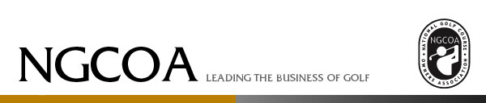

Your Data Privacy and Security is Important to Us
The National Golf Course Owners Association (NGCOA) recognizes the importance its members and other visitors place on privacy issues. In compliance with the New European General Data Protection Regulation (GDPR), we have updated our Privacy Policy effective May 25, 2018. This updated privacy policy statement describes the information we collect about you from the NGCOA sites and how we use that information. We suggest that you review the Privacy Policy periodically as we may update it as necessary.

Our statement also describes the choices you can make about how we collect and use your information. Please click ONLY ONE of the following buttons to:

1) consent to continue receiving communications from NGCOA, or

2) not give consent to continue receiving communications from NGCOA, and to be removed from our database.





